Video Based Fire Detection Using Deep Learning

Narayana Chakravarthi,Omshith R, Rayapudi Venkata Rahul ,Sravan Varma

Department of Computer Science and Engineering,

Amrita School of Engineering,

Amrita Nagar, Choodasandra,Junnasandra,Bangalore,Karnataka-560035, India

*Corresponding Author: bp_peeta@blr.amrita.edu, ORC ID: *0000-0003-2376-4591*

*Abstract*— **Accurate detection is essential for prompt reaction and fire mitigation since fires represent a serious hazard to people's lives and property. A family of deep learning models known as CNNs has demonstrated excellent potential in computer vision applications, such as fire detection. The abstract illustrates how CNNs may be used to accurately detect fire in a variety of situations by learning discriminative characteristics from pictures or video frames. Additionally, it examines the training procedure, the significance of data augmentation, and the structural elements of a typical CNN-based fire detection system.**

Keywords—fire detection, conventional neural network (CNN)

# INTRODUCTION

Early fire detection is essential for preventing catastrophic damage to property, infrastructure, and the environment. In complicated circumstances with several heat sources or smoke sources, traditional fire detection systems frequently rely on thermal sensors or smoke detectors, both of which have limits in their ability to detect fires reliably. Convolutional Neural Networks (CNNs) have gained more attention in recent years as a potential tool for fire detection. An example of a deep learning model is CNNs, which have demonstrated outstanding performance in computer vision applications including object identification and picture categorization.

This report's objective is to give a general review of CNN application in fire detection and examine both the possible benefits and drawbacks of this approach. CNNs have grown in prominence as a result of their capacity to automatically recognize hierarchical aspects from video or picture frames, allowing them to recognize intricate patterns and tell apart fire-related elements from unrelated elements. By using this capacity, CNNs may detect fires more precisely and reliably than conventional techniques.

CNNs have demonstrated encouraging results in fire detection, although there are still issues. The performance of the CNN model can be affected by elements including different lighting conditions, occlusions, and the existence of comparable heat sources. Additionally, getting high accuracy and efficiency in fire detection scenarios requires optimizing the CNN model's architecture and hyperparameters.

The use of CNNs for fire detection is the main topic of this paper, which also examines the benefits and drawbacks of this method. CNNs are a particular kind of deep learning model created for the purpose of removing significant characteristics from picture or video frames. They are excellent at learning hierarchical representations, which makes them suitable for identifying objects and patterns in visual input. Fire-related patterns may be efficiently separated from non-fire components by utilizing CNNs' capacity to automatically learn discriminative features.

This report's main goal is to give a general overview of CNN-based fire detection systems. It digs into the structural elements, such as convolutional layers, pooling layers, and fully linked layers, of a typical CNN model used for fire detection. It is described how the network is trained by supplying it with a sizable dataset of labelled fire and non-fire photos. The relevance of data augmentation strategies in enhancing the CNN model's resilience is also covered in the study.

Real-time monitoring and early warning systems are given intriguing new possibilities by the application of CNNs in fire detection. CNNs can quickly and automatically identify fires by analyzing picture or video frames, which helps to shorten reaction times and lower the possibility of serious injury or fatality. Additionally, the creation of reliable and adaptive fire detection systems that can function effectively in a variety of situations and conditions is made possible by the capacity to train CNN models on vast datasets of labelled fire and non-fire pictures.

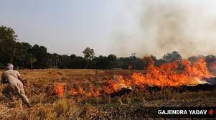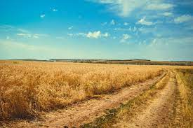

Fig1. Example image for fire and non-fire.

The use of CNN for fire detection has the potential to significantly improve fire safety procedures, facilitate early fire detection, and ultimately save lives and property. The capabilities of CNN-based fire detection systems may be further improved via ongoing research, innovation, and collaboration in this area, making them an essential component of all-encompassing fire prevention and mitigation methods.

# Literature Survey

[1] The paper "A Review of Video-Based Fire Detection Systems" by Shuo Chen et al. (2019) is a comprehensive survey of the state-of-the-art in video-based fire detection systems. It covers various techniques used in video-based fire detection, including traditional methods based on color and motion analysis, as well as newer deep learning-based methods. The authors highlight the importance of early detection in preventing fires from spreading and causing significant damage and provide an overview of the different types of sensors and techniques used for fire detection. The paper focuses specifically on video-based fire detection systems, discussing various approaches and datasets used to train and evaluate such systems. The challenges associated with developing accurate and reliable fire detection systems under various lighting and environmental conditions are also discussed. The paper concludes by summarizing the key findings and highlighting promising areas for future research in video-based fire detection systems. Overall, it provides a valuable resource for researchers and practitioners interested in developing and deploying video-based fire detection systems.

[5] An adaptive threshold deep learning method for fire and smoke detection by X. Wu, X. Lu and H. Leung, 2017 IEEE International Conference on Systems, Man, and Cybernetics (SMC), Banff, AB, Canada, 2017.A vital role in preserving public safety and reducing property damage is fire and smoke detection. The accuracy and dependability of traditional fire and smoke detection techniques are constrained. Deep learning algorithms have made significant progress in recent years in terms of increasing the precision of fire and smoke detection systems. One such methodology is the adaptive threshold deep learning method, which boosts detection accuracy by combining deep learning methods with adaptive thresholding. We address the benefits and drawbacks of the adaptive threshold deep learning approach for fire and smoke detection in this research. Using a collection of photos of fire and smoke, a deep learning model is trained using the adaptive threshold deep learning technique. The model gains the ability to differentiate between background noise and patterns of fire and smoke. After that, the model is integrated with an adaptive thresholding method, which modifies the detection threshold according on the specifics of the local picture. The system can identify fire and smoke patterns in photographs with various backgrounds and lighting conditions thanks to the adaptive thresholding method. Over conventional fire and smoke detection techniques, the adaptive threshold deep learning method provides a number of benefits. First, compared to rule-based systems and sensor-based technologies, it is more accurate and trustworthy. Second, because it can adjust to varied backdrops and lighting conditions, it may be used in a variety of settings. Thirdly, because it may be applied in real-time scenarios, it is helpful for monitoring and surveillance. A potential method for detecting fire and smoke is adaptive threshold deep learning. To increase detection accuracy and flexibility to changing backdrops and lighting conditions, it blends deep learning techniques with adaptive thresholding. To enhance the method's performance and investigate its efficacy in various contexts, more study is necessary. The technique is an effective tool for fire and smoke detection since it has the ability to increase public safety and reduce property damage.

[3] The authors introduce the importance of fire detection in various applications, such as early fire warning systems and video surveillance. They highlight the challenges of accurate fire detection due to the complex and diverse nature of fire appearances in images. The authors discuss previous research on fire detection using different techniques, including rule-based methods, template matching, and machine learning approaches. They mention the limitations of traditional methods, such as sensitivity to environmental conditions and the need for manually crafted features. The authors outline their suggested SVM-based fire detection approach. They describe the whole method, which includes feature extraction, preprocessing procedures, and SVM classification. On a dataset that includes photos of fire and images without fire, the authors do tests. They contrast the performance of the suggested SVM-based technique with that of alternative methods like artificial neural networks (ANN) and k-nearest neighbors (KNN). The efficacy of the approach is evaluated using measures including accuracy, precision, recall, and F1 score. The results of the experiments show that the suggested SVM-based technique performs competitively in terms of fire detection. The benefits of SVM in managing high-dimensional feature spaces and its capacity for generalization are covered by the authors. The conclusions of the research summarize the results and contributions of the suggested SVM-based fire detection system. The authors highlight the usefulness of SVM as a classification system for detecting fires and offer possible lines of further investigation.

[6] The need of early wildfire identification for successful fire management and prevention is discussed by the writers. They talk about how complicated and varied the visual qualities of fire in video footage make it difficult to spot wildfires in time. The study provides a review of deep learning methods used for video image wildfire detection. It talks about how deep learning is better at handling complicated data and automatically developing discriminative features. The authors demonstrate their deep learning and Hidden Markov Models (HMM)-based wildfire detection approach. They outline the whole procedure, which includes data preparation, feature extraction using a deep learning model that has already been trained, and wildfire identification using HMM. Techniques like frame differencing, resizing, and normalization may be used in data preparation. The convolutional neural network (CNN), a type of deep learning model, is used to extract high-level properties from video frames. An HMM-based classifier is then used to predict the temporal dynamics and identify wildfires using the retrieved characteristics. A collection of video pictures with incidences of wildfire and non-wildfire is used by the authors in their research. Utilizing criteria like accuracy, precision, recall, and F1 score, they assess the efficacy of the suggested strategy. It is compared to various techniques, including deep learning technologies and conventional image processing. The experimental findings show how well the suggested strategy for detecting wildfires works. The benefits of integrating deep learning with HMM for extracting spatial and temporal information from video pictures are discussed by the authors. The contributions and conclusions of the proposed deep learning and HMM-based wildfire detection approach are summarized in the paper's conclusion. The authors go over the method's possible uses and effects on early fire alerting systems.

# Data Exploration

Exploring the data before training an MLP model for fire detection is an important step in the deep learning pipeline. Here are some examples of data exploration techniques that can be applied to a fire detection dataset:

Data visualization: Plotting the images from the dataset can reveal information about the distribution of the data, the balance between the classes, and any potential data quality problems. To check if there are any obvious differences between fire and non-fire photos, it may be useful to plot the distribution of pixel values for both types of photographs.

Data Augmentation: In applications for fire detection, the model can be strengthened by creating more training instances using data augmentation approaches. Typical picture augmentation methods include random translation, scaling, rotation, and flipping.

Feature Extraction: Fire detection photos might contain a variety of information, not all of which may be pertinent for the classification assignment. This is known as feature extraction. The dimensionality of the input data can be decreased by using feature extraction techniques to extract pertinent features from the photos. The MLP model's effectiveness and accuracy may be enhanced as a result.

Class Imbalance: The number of non-fire photographs may be significantly higher than the number of fire images in many datasets for fire detection. This disparity in class can lead to biased models that underperform for minority classes. To balance the classes and enhance model performance, strategies like oversampling or under sampling can be applied.

# IV. Models used for fire detecion

A. Multi-Layer Perceptron:

The model was trained and evaluated on a dataset of images containing both fire and non-fire images. The MLP model had three hidden layers with 64 ,128 and 256neurons, respectively, and a dropout layer with a rate of 0.2 after each hidden layer. The model used Re-LU activation function for the hidden layers and a sigmoid activation function for the output layer, which outputs the probability of the input image containing fire. The model was trained for 35 epochs using batches of 32 images. The training process used early stopping with a patience of 5 epochs to prevent overfitting. The training accuracy was around 86%, while the validation accuracy was around 83%

An intriguing technology that provides an alternative to CNN-based fire detection is Multi-Layer Perceptron (MLP). MLP is a feedforward neural network design made up of several linked layers of neurons. MLPs can be used for fire detection even if CNNs are more popular for computer vision tasks. When using MLP for fire detection, the network must first be trained using a dataset of photos of fire and images of non-fire. The MLP then learns to categorize the input images using learnt characteristics. MLPs may capture intricate correlations between input characteristics and work well with structured data. As a result, they may be useful for spotting fire-related patterns and separating them from other aspects.

By carefully choosing hyperparameters and model architecture, as well as by utilizing high-quality training data, it is possible to enhance an MLP's performance. the model that was trained and the associated summary for the MLP model is:

The fig2 explains the convo2D after that with max pooling again the repeat later do the flatten for making 1D vector. After making the dense layer the parameters are 2,21,51,425.

The total parameters after MLP are 2,22,44,929.

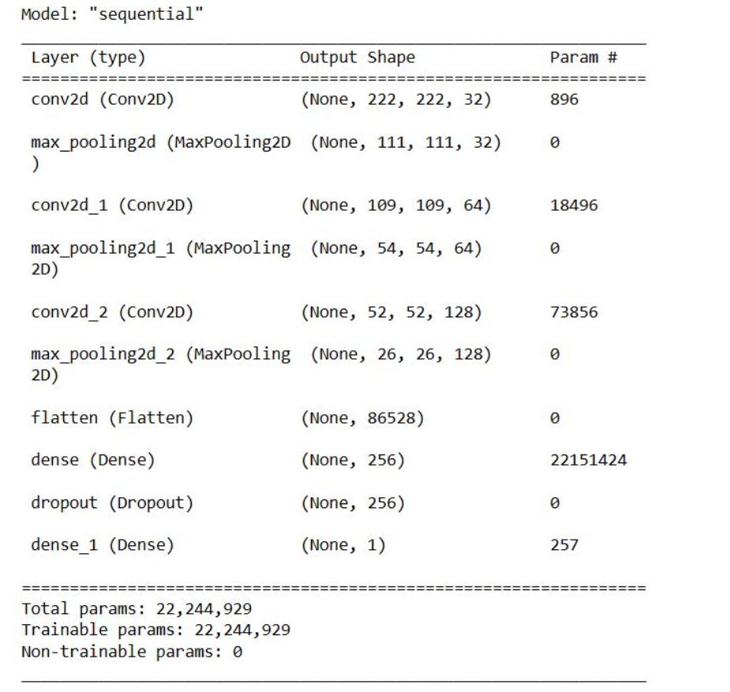

Fig2. MLP Model Summary

B. Convolution Neural Network

The model was trained and evaluated on a dataset of images containing both fire and non-fire images using the CNN model. This is a basic convolutional neural network (CNN) architecture for image classification tasks. The layers that we used333x in our CNN model:

Conv2D layer uses 64 filters to the input picture, each measuring 3x3. The input form of the photos is (100, 100, 3), which indicates that each image has three color channels and a height and width of 100 pixels (RGB). The output of this layer will be a feature map with 64 channels from fig4. The Rectified Linear Unit () activation function is applied to the output of the preceding layer by the Re-LU activation function. The MaxPooling2D layer applies max pooling to the output of the preceding layer with a pool size of 2x2. The output of the preceding layer is flattened into a 1D vector by the flatten layer. To transfer the data to the fully linked levels, this is required. The dense layer, which applies a fully linked layer to the flattened input, comprises 64 neurons. This layer uses the SoftMax activation function, which guarantees that the output values are probabilities that add to 1.

Model that has been used for training and the corresponding summary for the CNN model is:

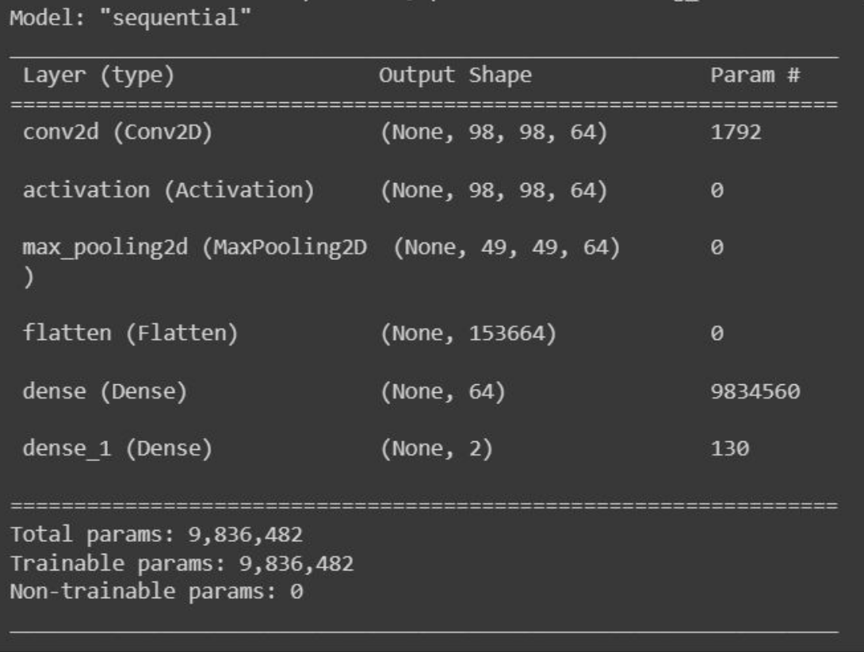

Fig 3. CNN Model Summary.

The Fig3 image explains about the model that we used for CNN and then we used convolution2d, activation function as Re-LU and max pooling to reduce the dimension used flatten and then we got the output us 98*98*64*64 output parameters 153664 and 2 dense layer functions.

# V.Research Questions

1. How can video data be enhanced and preprocessed to perform fire detection more effectively?

Resizing frames, normalizing pixel values, and using temporal transformations like optical flow or frame differencing are all ways to preprocess video data. Techniques for enhancing the training data, such as random cropping, flipping, rotating, and introducing noise, can also be employed to broaden the variety of the data and strengthen the model's robustness.

1. What network architectures are appropriate for video-based fire detection?

Two-stream networks, in which one stream processes spatial information from individual frames and the second stream processes temporal information across frames, are among the network architectures that are suited for video-based fire detection. Other architectures, such as 3D CNNs, which can concurrently record spatial and temporal characteristics, have also demonstrated potential in this area.

1. How can video-based fire detection use transfer learning?

Transfer learning can be used for video-based fire detection by using pre-trained models that have been optimized on a smaller fire detection dataset. These models have been trained on large-scale datasets like ImageNet. This method enhances the performance of fire detection models with little training data by utilizing the learned features from the pre-trained models.

1. What are the difficulties and restrictions of deep learning-based video-based fire detection?

The following issues and restrictions apply to video-based fire detection utilizing deep learning techniques:

* Lack of annotated fire video collections makes it difficult to develop reliable models.
* The capacity of the models to generalize can be impacted by variations in fire appearances, such as different fire types, sizes, and intensities.
* Resources needed and computational complexity for real-time applications processing video data.
* false positive fire detections brought on by non-fire phenomena like smoke, flashing lights, or similar circumstances.

1. How can the performance of video-based fire detection systems be evaluated?

Metrics including accuracy, precision, recall, F1 score, and area under the receiver operating characteristic curve (AUC-ROC) can be used to gauge how well video-based fire detection systems operate. Computational effectiveness, detection time, and the capacity to handle various fire scenarios may all be added evaluation factors.

# VI. Failure Causes

The appearance of fires can vary depending on their types, intensities, sizes, and surrounding conditions. The models can find it difficult to correctly detect fires in real-world circumstances if the training data does not appropriately account for these differences. This problem can be addressed by include a variety of fire cases in training or by investigating methods that can deal with different fire appearances, like domain adaptation or generative adversarial networks.

Real-Time Processing and Computational Complexity: In real-time circumstances, where video-based fire detection systems frequently operate, deep learning models' computational cost can be a constraint. Complex models may have trouble performing in real time on devices with limited resources or in high-throughput applications. These difficulties can be overcome by using optimizations such model compression, quantization, or lightweight designs, which allow real-time fire detection without sacrificing accuracy.

For fire detection, deep learning models generally rely on visual cues. However, there may be circumstances in which fires are only partially visible, concealed by items, or located in dimly light areas. In these circumstances, relying only on visual data may lead to missed detections. These restrictions can be solved, and the performance of fire detection as a whole, by investigating the integration of thermal imaging or other complementary sensing methods with visual data.

# VII. Results

A. Multi-layer perceptron

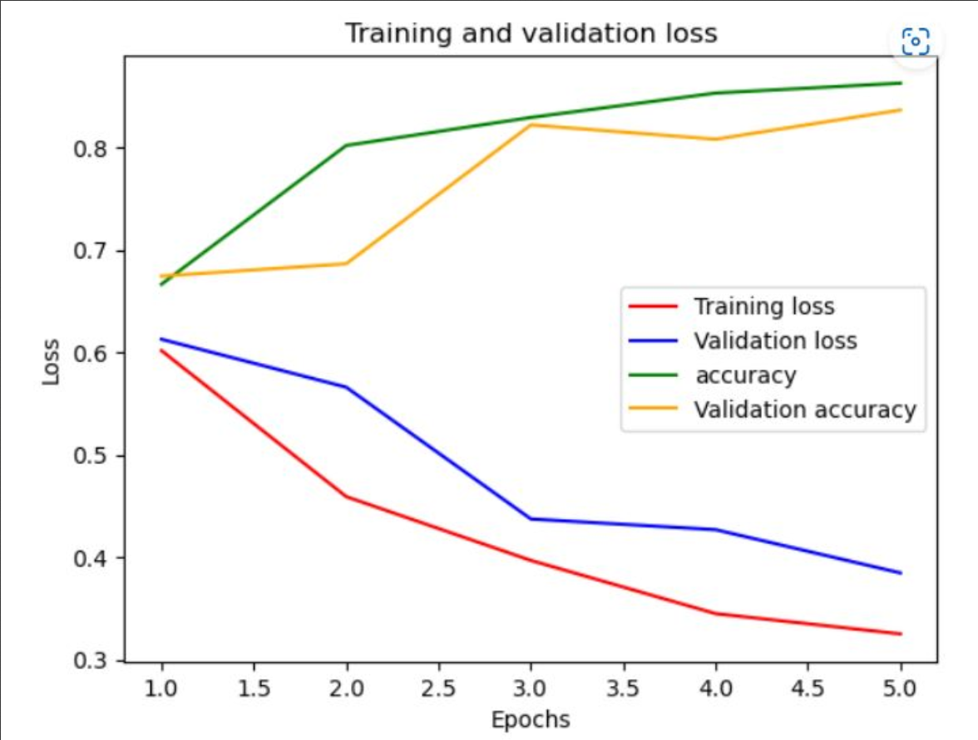

Fig5.Graph of training loss and validation loss for MLP

From fig5 see that the training loss and validation loss decrease over epochs, and the validation loss and training loss doesn’t seem to increase, which is a good sign of regular fit.

B. Convolution-Neural Network:

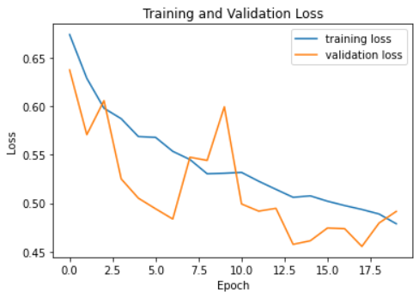

Fig6.Graph of training loss and validation loss for CNN

From the image after first epoch validation loss crossed the training loss. It is also a good sign for the regular fit.

# VI. Conclusion:

A. Multi-layer Perceptron

Fire detection using MLP (Multi-Layer Perceptron) is a reliable and efficient way to detect fire. MLP is a type of neural network that is trained on a large dataset of fire images and can identify patterns in the images that indicate the presence of a fire. A number of fire features, including color, texture, and size, may be taught to the MLP model. Additionally, the model may be improved to lower false alarm rates and raise accuracy. In general, applying an MLP model for fire detection can result in quick and precise outcomes.

B. Convolution Neural Network

Real-time fire detection using CNN (Convolutional Neural Network) is a very efficient and precise technique. The CNN neural network type is highly suited for image-based fire detection since it is made to analyze and interpret visual input. A quick and reliable method of spotting fires and reducing damage is to use a CNN model for fire detection. To guarantee optimal safety, CNN models should be used in conjunction with other fire protection measures like smoke detectors and fire alarms, much like with MLP.

Table5.Results of the various models

|  |  |  |  |
| --- | --- | --- | --- |
| S.no | Classifier | Training Accuracy | Testing Accuracy |
| 1. | MLP | 86.26 | 83.66 |
| 2. | CNN | 79.57 | 80.11 |

The above table gives the training accuracies and testing accuracies of the both models MLP and CNN. After seeing the results CNN gave better accuracies because the video images needed to extract more filters CNN helped us to extract more which helps to say whether Fire and Non-Fire.

##### References

1. "A Review of Video-Based Fire Detection Systems" by Shuo Chen et al. (2019)
2. O. Maksymiv, T. Rak and D. Peleshko, "Real-time fire detection method combining AdaBoost, LBP and convolutional neural network in video sequence," 2017 14th International Conference The Experience of Designing and Application of CAD Systems in Microelectronics (CADSM), Lviv, Ukraine, 2017, pp. 351-353, doi: 10.1109/CADSM.2017.7916148.
3. K. Chen, Y. Cheng, H. Bai, C. Mou and Y. Zhang, "Research on Image Fire Detection Based on Support Vector Machine," 2019 9th International Conference on Fire Science and Fire Protection Engineering (ICFSFPE), Chengdu, China, 2019, pp. 1-7, doi: 10.1109/ICFSFPE48751.2019.9055795.
4. A. Bari, T. Saini and A. Kumar, "Fire Detection Using Deep Transfer Learning on Surveillance Videos," 2021 Third International Conference on Intelligent Communication Technologies and Virtual Mobile Networks (ICICV), Tirunelveli, India, 2021, pp. 1061-1067, doi: 10.1109/ICICV50876.2021.9388485.
5. X. Wu, X. Lu and H. Leung, "An adaptive threshold deep learning method for fire and smoke detection," 2017 IEEE International Conference on Systems, Man, and Cybernetics (SMC), Banff, AB, Canada, 2017, pp. 1954-1959, doi: 10.1109/SMC.2017.8122904.
6. K. -M. Hung, L. -M. Chen and J. -A. Wu, "Wildfire Detection in Video Images Using Deep Learning and HMM for Early Fire Notification System," 2019 8th International Congress on Advanced Applied Informatics (IIAI-AAI), Toyama, Japan, 2019, pp. 495-498, doi: 10.1109/IIAI-AAI.2019.00107.
7. Chi, R.; Lu, Z.M.; Ji, Q.G. Real-time multi-feature based fire flame detection in video. IET Image Process. 2016, 11, 31–37.
8. Xiaogang Wang, Deep Learning in Object Recognition, Detection, and Segmentation , now, 2016.
9. A. S. Abdullahi Madey, A. Yahyaoui and J. Rasheed, "Object Detection in Video by Detecting Vehicles Using Machine Learning and Deep Learning Approaches," 2021 International Conference on Forthcoming Networks and Sustainability in AIoT Era (FoNeS-AIoT), Nicosia, Turkey, 2021, pp. 62-65, doi: 10.1109/FoNeS-AIoT54873.2021.00023.
10. C. Hary and S. Mandala, "Object Detection Analysis Study in Images based on Deep Learning Algorithm," 2022 International Conference on Data Science and Its Applications (ICoDSA), Bandung, Indonesia, 2022, pp. 226-231, doi: 10.1109/ICoDSA55874.2022.9862922.
11. K. Muhammad, J. Ahmad, Z. Lv, P. Bellavista, P. Yang and S. W. Baik, "Efficient Deep CNN-Based Fire Detection and Localization in Video Surveillance Applications," in IEEE Transactions on Systems, Man, and Cybernetics: Systems, vol. 49, no. 7, pp. 1419-1434, July 2019, doi: 10.1109/TSMC.2018.283009